Product Date sheet
Linear series

IP20
TECHNICAL DRAWINGS

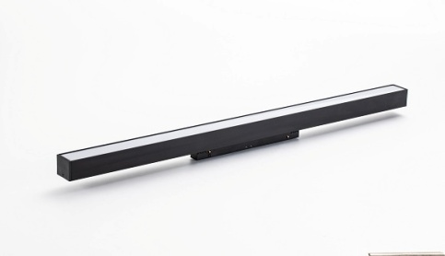

Product Code: Linear series

DESIGN BY
Emilux architecture
DESCRIPTION
Opal lighting for general use and outlining
Average lighting on opal cover
Average performance within differernt length
External dimming interface withTriac,0/1-10V,Dali

FEATURES  Article Code:  Colour:  Installation:  Environment:  GENERAL SPECIFICATION |  | Linear series  Black/White  Magnetic  Indoor
CCT:  CRI:  LED:  DIM: | 2700K/3000K/4000K  RA90  OSRAM  Triac,0/1-10V,Dali
AVAILABLE MODELS
Item Power(w) Size(mm)
EM-S20F4-10W 10W L300*W22*H45mm
EM-S20F4-20W | 20W | L600*W22*H45mm
EM-S20F4-30W | 30W | L900*W22*H45mm
EM-S20F4-40W | 40W | L1200*W22*H45mm
PACKAGE INFORMATION
Item Qty/Ctn(pcs) N.W/Ctn(kgs) G.W/Ctn(kgs) L*W*H(cm)
EM-S20F4-10W 20 5.7 7.5 44.5x22.24
EM-S20F4-20W | 20 | 9.8 | 12.2 | 44.5x38x28
EM-S20F4-30W | 10 | 9.1 | 11.7 | 70x18.5x35
EM-S20F4-40W | 10 | 14 | 16.3 | 101x17.5x36
LIGHT DISTRIBUTION
