IP20
TECHNICAL IMAGE
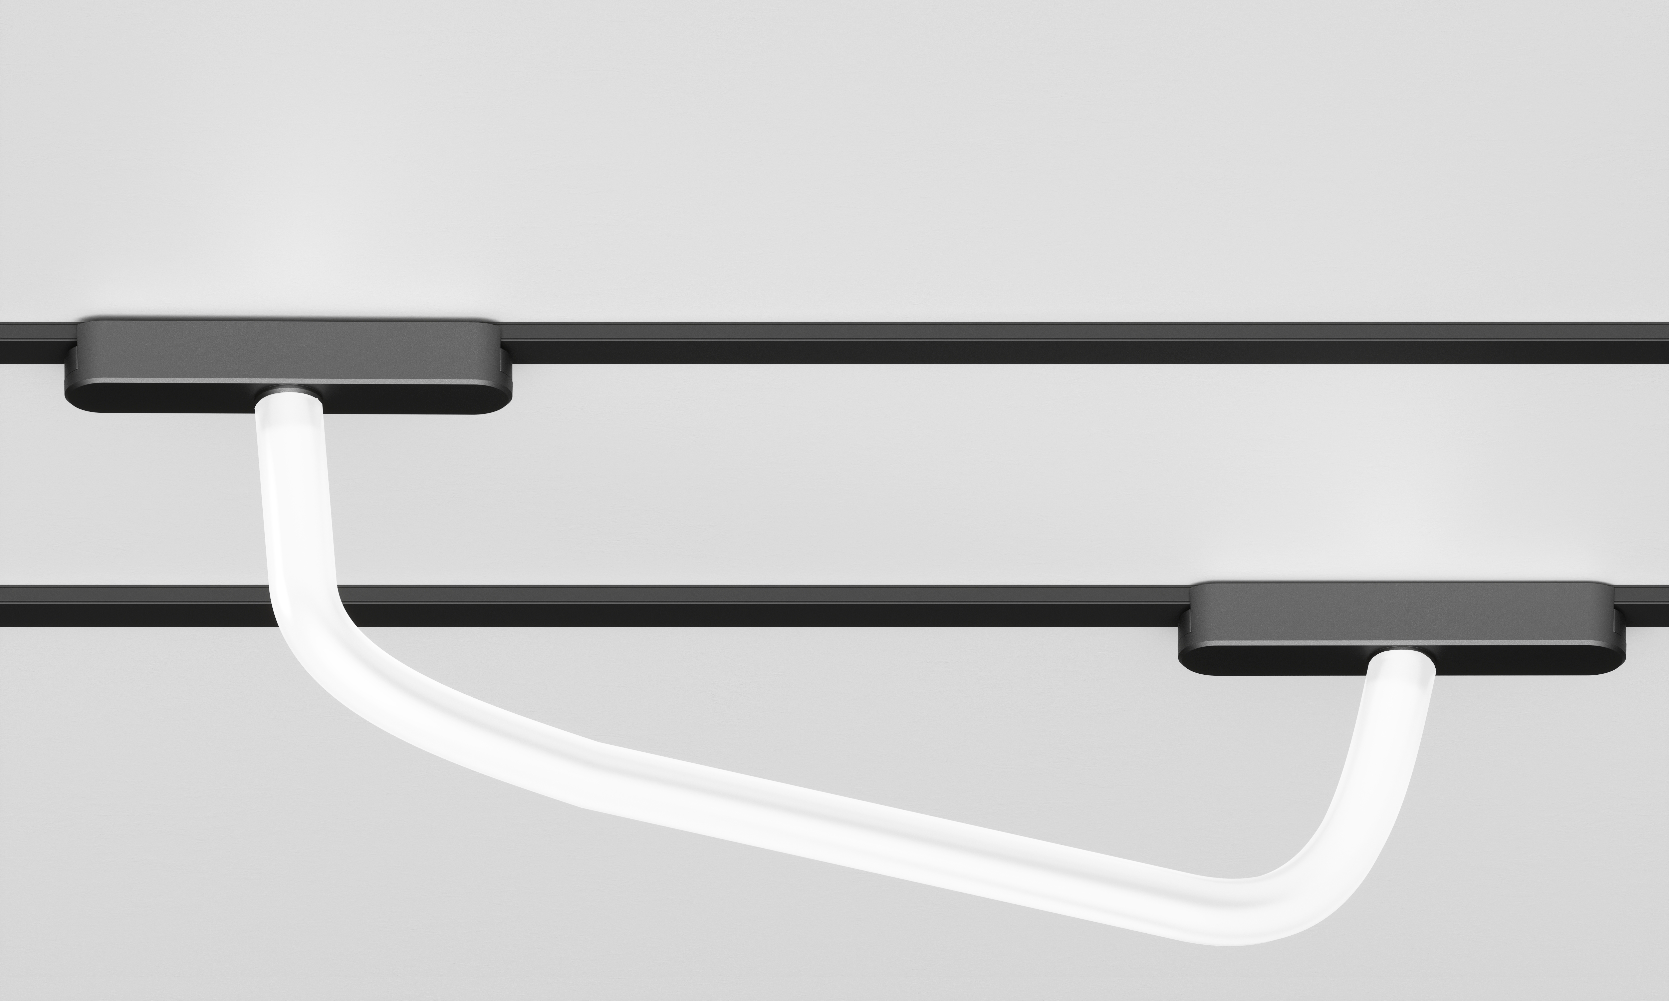

DESIGN BY

Emilux Lighting Limited

DESCRIPTION
- Multi power for commercial and architectural lighting
- Average lighting with Silicone material
- Average performance within different dimension
- External dimming system: Triac/ 0-10V/ Dali/Bluetooth/ Tuya/ Zigbee

FEATURES  Name:  Colour:  Installation:  Application: |  | Track tube light  Matt black  Magnetic  Indoor
CCT:  Ra:  LED Chip:  Beam Angle:  Lumen: | 3000K/4000K/5000k  ≧90  Sanan  360°  620(12w)/ 1000(20w)lm
AVAILABLE MODELS
Item | Power(w) | Size(mm)
EM-EH-GJ-1000 | 12 | ø22*1000
EM-EH-GJ-2000 | 20 | ø22*2000

