IP20
TECHNICAL IMAGE
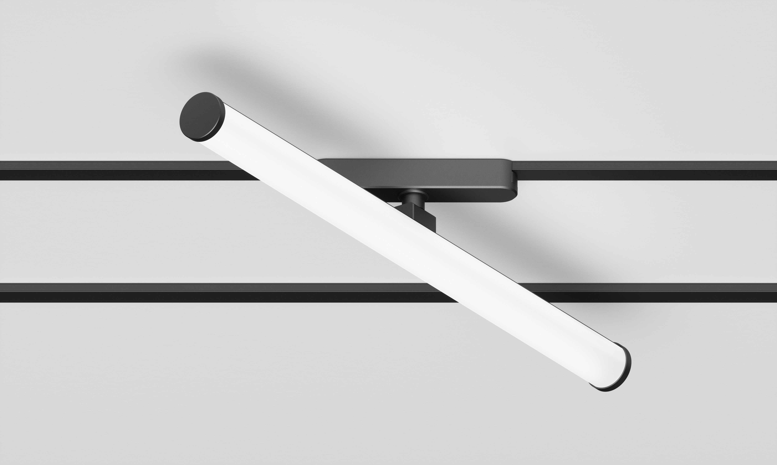

DESIGN BY

Emilux Lighting Limited

DESCRIPTION
- Multi power for commercial and architectural lighting
- Average lighting with die-casting Aluminium material
- Average performance within different dimension
- External dimming system: Triac/ 0-10V/ Dali/Bluetooth/ Tuya/ Zigbee

FEATURES  Name:  Colour:  Installation:  Application: |  | Track mobile tube light  Matt black  Magnetic  Indoor
CCT:  Ra:  LED Chip:  Beam Angle:  Lumen: | 3000K/4000K/5000k  ≧90  OSRAM  120°  660(12w)/ 950(18w)/ 1300(24w)lm
AVAILABLE MODELS
Item | Power(w) | Size(mm)
EM-EH-GG-500 | 12 | L500*W35*H79
EM-EH-GG-1000 | 18 | L1000*W35*H79
EM-EH-GG-1500 | 24 | L1500*W35*H79

